Test Case: tc001_SPX_Dev5_Consulta_Administracion_Accesos
Step 1 - Enter username and password and click to button Enter : Credentials Entered
Image file-name: QC_Testing-tc001_SPX_Dev5_Consulta_Administracion_Accesos-dic. 19 2025, 04 58 52 p. m.

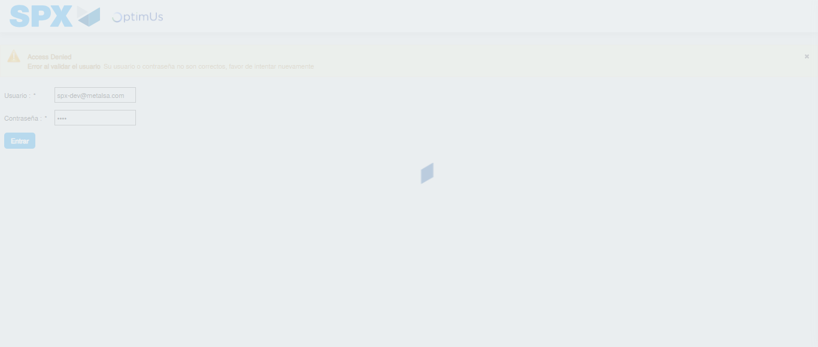Image file-name: QC_Testing-tc001_SPX_Dev5_Consulta_Administracion_Accesos-dic. 19 2025, 04 58 53 p. m.

Step 2 - Select to UEN and Access to Administración de Accesos: UEN Correctly selected and Correct access
Image file-name: QC_Testing-tc001_SPX_Dev5_Consulta_Administracion_Accesos-dic. 19 2025, 04 58 57 p. m.

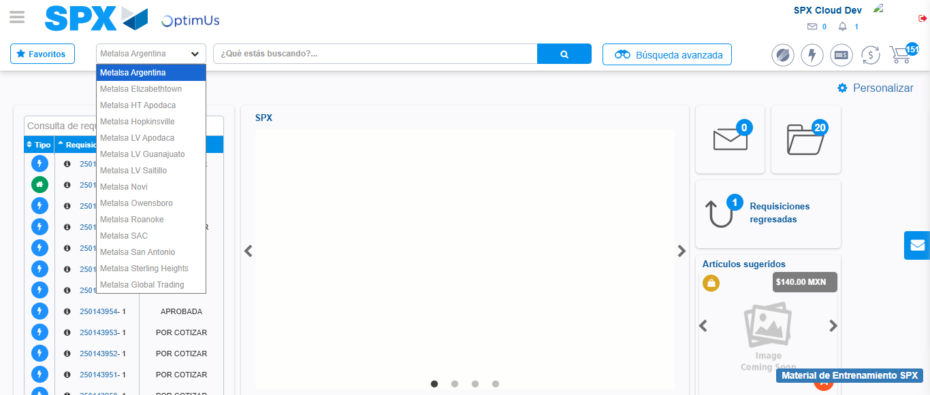Image file-name: QC_Testing-tc001_SPX_Dev5_Consulta_Administracion_Accesos-dic. 19 2025, 04 58 58 p. m.

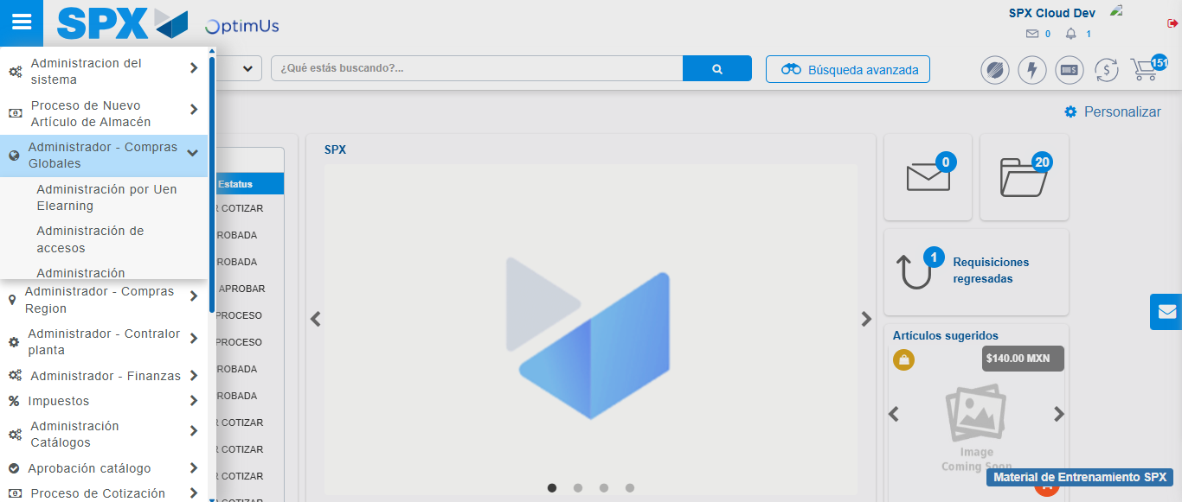Image file-name: QC_Testing-tc001_SPX_Dev5_Consulta_Administracion_Accesos-dic. 19 2025, 04 58 59 p. m.

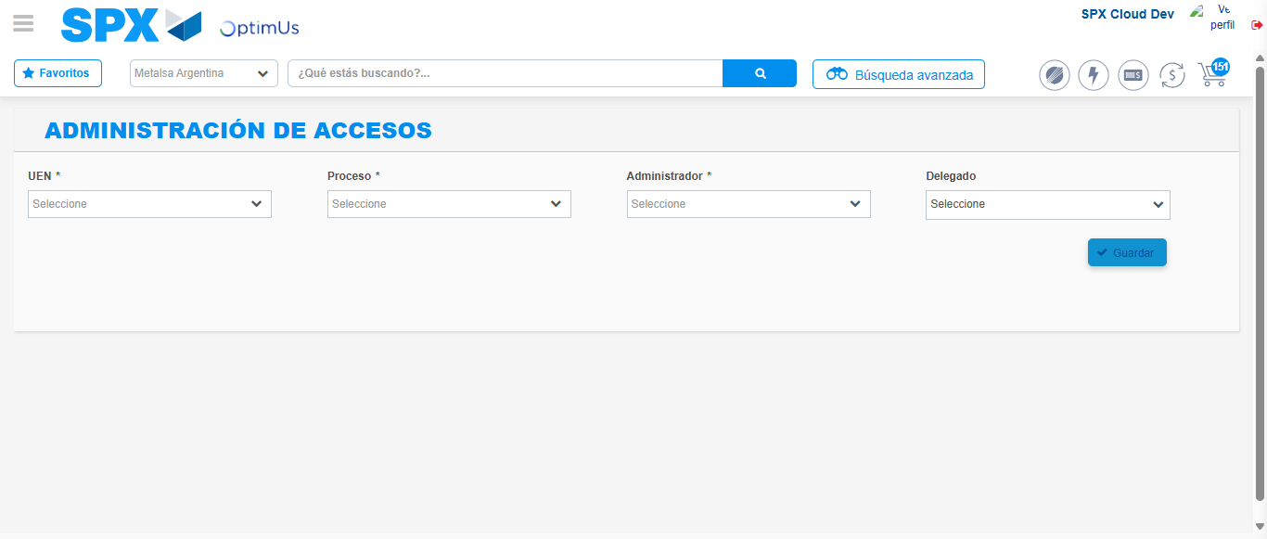Image file-name: QC_Testing-tc001_SPX_Dev5_Consulta_Administracion_Accesos-dic. 19 2025, 04 59 02 p. m.

Image file-name: QC_Testing-tc001_SPX_Dev5_Consulta_Administracion_Accesos-dic. 19 2025, 04 59 03 p. m.

